**Preparation of Nanostructured Holmium oxide by A Simple Process**

**Sahar Zinatloo-Ajabshir1*, Ghader Hosseinzadeh1**

|  |  |
| --- | --- |
| 1* Department of Chemical Engineering, University of Bonab, Bonab, Iran | s.zinatloo@ubonab.ac.ir, s.zinatloo@gmail.com |
|  |
|  |

**Abstract**

In this investigation, nanostructured holmium oxide was fabricated through a new and simple way. The efficacy of some synthesis parameters was examined to reach optimum condition. Outcomes of this research illustrate that morphology and dimension of the holmium oxide could be substantially influenced via these parameters. The as-produced holmium oxide nanostructure was characterized by FT-IR, FESEM, EDS and XRD. According to the obtained outcomes, it was found that with the aid of this new approach can be synthesized homogeneous nanostructured holmium oxide. The photocatalyst yield of as-fabricated holmium oxide was also examined by elimination of the organic pollutant under visible light irradiation.

**Keywords:** Holmium oxide, Nanostructure, FESEM, Photocatalytic activity

**Introduction**

The preparation of nanomaterials has attracted wonderful attention because of their usages in various areas and specific features [1, 2]. Among these nanostructured compounds, holmium oxide is currently the focus of substantial interest owing to its potential utilizations, including pyrolysis catalysts and wavelength-calibration instruments [3, 4]. Up to now, the thermal decomposition method has been utilized to fabricate holmium oxide [5, 6]. In this investigation, nanostructured holmium oxide was fabricated through a new and simple way. The efficacy of some synthesis parameters was examined by utilizing field emission scanning electron microscopy (FESEM). The as-produced holmium oxide nanostructure was characterized by FT-IR, FESEM, EDS and XRD. The as-produced holmium oxide nanostructure was employed as a nanocatalyst for the elimination of the organic pollutant.

**Materials and Method**

All the chemical reagents employed in our research were of analytical grade and were applied as received without additional purification. Fourier transform infrared (FT-IR) spectrua of the as-prepared holmium oxide nanostructure were recorded on Varian 4300 spectrophotometer in KBr pellets. Microscopic morphology of as-synthesized holmium oxide nanostructure was visualized by a Tescan mira3 field emission scanning electron microscope. Powder X-ray diffraction (XRD) pattern of the as-produced holmium oxide nanostructure were collected from a diffractometer of Philips Company with X’PertPro monochromatized Cu Ka radiation (k = 1.54 Å). Holmium oxide nanostructure were fabricated through a new and simple way. At first, aqueous solution of propylenediamine as new precipitator

was added to aqueous solution of holmium source and trisodium citrate as capping agent. To obtain the final product, the as-produced precipitate was washed, dried and calcined at certain temperature in the air.

**Results and Discussion**

In the FTIR spectrum, the band at 550 cm-1 may be ascribable to the ν(Ho–O) vibration, which reflect the fabrication of holmium oxide [7].

In order to examine the structural features and mean crystallite size of the as-produced nanomaterials, powder X-ray diffraction technique was utilized. Fig. 1 exhibits XRD pattern of as-synthesized holmium oxide. All the diffraction bands in XRD pattern of the as-fabricated sample can be indexed to pure holmium oxide with cubic phase (JCPDS No. 83-0932).

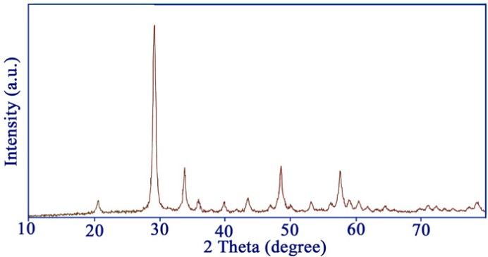

Figure 1: XRD pattern of as-synthesized holmium oxide nanostructure

The mean crystallite size of the as-fabricated holmium oxide nanomaterials was estimated from Scherrer equation [8] given by the following equation:

$$τ=\frac{kλ}{βcosϴ} (1)$$

where, λ is the wavelength of X-ray, K is the so-called

shape factor, β is the breadth of the observed diffraction line at its half intensity maximum and τ is the crystallite size. The mean crystallite diameter of the as-produced holmium oxide sample was about 17 nm.

Fig. 2 denotes FESEM images of as-prepared holmium oxide nanomaterials.

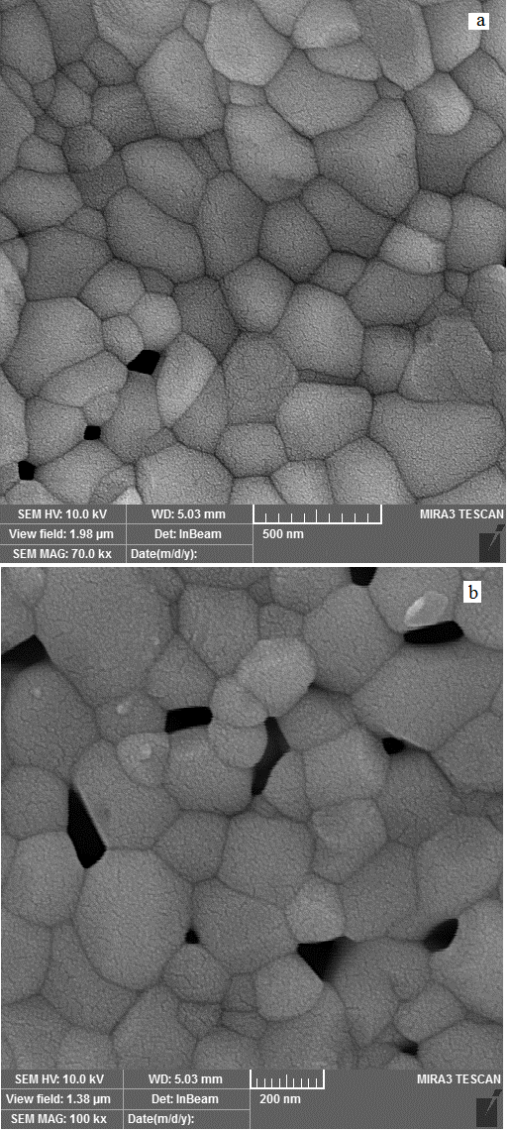

Figure 2: FESEM images of as-synthesized holmium oxide nanostructure

The as-produced holmium oxide nanomaterial was employed as a nanocatalyst for the photodegradation of Acid red 14. Based on the photocatalytic test outcomes, it was found that as-produced homogeneous holmium oxide nanomaterials exhibits great photocatalytic performance (about 79%) and may be applied as an efficient candidate for photocatalytic uses under visible light illumination.

**Conclusions**

This research demonstrated that homogeneous holmium oxide nanomaterials can be produced employing propylenediamine as new precipitator via an easy way. The as-produced holmium oxide nanomaterial was employed as a nanocatalyst for the photodegradation of Acid red 14. The photocatalytic test outcomes suggest as-formed holmium oxide nanomaterials as an efficient candidate for photocatalytic utilizations under visible light illumination.

**Acknowledgment**

Authors are grateful to University of Bonab for supporting this work

**References**

[1] T. Cheng, H. Gao, X. Sun, T. Xian, S. Wang, Z. Yi, G. Liu, X. Wang, H. Yang, An excellent Z-scheme Ag2MoO4/Bi4Ti3O12 heterojunction photocatalyst: Construction strategy and application in environmental purification, Advanced Powder Technology, 32 (2021) 951-962.

[2] J. Liu, J. Li, F. Wei, X. Zhao, Y. Su, X. Han, Ag–ZnO submicrometer rod arrays for high-efficiency photocatalytic degradation of Congo red and disinfection, ACS Sustainable Chemistry & Engineering, 7 (2019) 11258-11266.

[3] J.A. Vaccari, Materials handbook, McGraw Hill Professional2002.

[4] G.A. Mekhemer, Surface acid–base properties of holmium oxide catalyst: in situ infrared spectroscopy, Applied Catalysis A: General, 275 (2004) 1-7.

[5] M. Abdusalyamova, F. Makhmudov, E. Shairmardanov, I. Kovalev, P. Fursikov, I. Khodos, Y. Shulga, Structural features of nanocrystalline holmium oxide prepared by the thermal decomposition of organic precursors, Journal of alloys and compounds, 601 (2014) 31-37.

[6] V. Glushkova, A. Boganov, Polymorphism of rare-earth sesquioxides, Bulletin of the Academy of Sciences of the USSR, Division of chemical science, 14 (1965) 1101-1107.

[7] L.S. El-Deen, M.S. Al Salhi, M.M. Elkholy, IR and UV spectral studies for rare earths-doped tellurite glasses, Journal of Alloys and Compounds, 465 (2008) 333-339.

[8] R. Jenkins, R.L. Snyder, Introduction to X-ray Powder Diffractometry (Volume 138), Wiley Online Library1996.