**Mechanical property Estimation of functionalized graphene nanocomposite using machine learning and its use-case in buckling response**

**Farzad Ebrahimi1*, Hosein Ezzati2**

|  |  |  |
| --- | --- | --- |
| 1*Faculty of Mechanical Engineering Department, Imam Khomeini International University | | febrahimy@eng.ikiu.ac.ir |
| 2BSc Student, Mechanical Engineering Department, Imam Khomeini International University | | itshoseinezzati@gmail.com |
|  |

**Abstract**

In this paper, a machine learning model is developed to approximate the Functionalized graphene (FG) nanocomposite’s young’s moduli in various temperatures. The machine learning model which is based on regression will find the appropriate function to estimate the temperature-dependent moduli of the FG nanocomposite and neat epoxy. Afterward, the governed mathematical expressions are used to solve the buckling problem of an FG nanocomposite beam. To achieve this goal, an energy-based technique including the shear deformable beam hypothesis is utilized. Also, the Navier’s method is used to derive the governing equations needed to find the critical buckling response when the beam is exposed to a temperature gradient. Comparisons between the results of our work with the ones reported in the literature indicate impressive precision of the presented machine learning model, as well as, the buckling response of the structure under study. Finally, the impact of some parameters including the temperature gradient, and slenderness ratio on the buckling of the proposed beam structure are presented in a framework of numerical case studies. The results of this study show that temperature plays a vital role in both young’s modulus of functionalized graphene, and the buckling load that beams fabricated from nanocomposites reinforced with functionalized graphene can tolerate.

**Keywords:** Machine learning, Functionalized graphene nanocomposite, Thermal buckling, Shear deformable beam.

**تخمین خاصیت مکانیکی نانوکامپوزیت گرافن عمل­آوری شده با یادگیری ماشین و بدست آوردن پاسخ کمانش آن**

**فرزاد ابراهیمی1*، حسین عزتی2**

|  |  |
| --- | --- |
| febrahimy@eng.ikiu.ac.ir | 1*عضو هیات علمی گروه مهندسی مکانیک، دانشکده فنی و مهندسی دانشگاه بین­المللی امام خمینی |
| itshoseinezzati@gmail.com | 2دانشجوی کارشناسی مهندسی مکانیک، دانشکده فنی و مهندسی دانشگاه بین­المللی امام خمینی |

# چكيده

در این مقاله، یک مدل یادگیری ماشینی برای تقریب مدول یانگ نانوکامپوزیت تقویت شده با گرافن عمل­آوری شده (FG) در دماهای مختلف توسعه داده شده است. مدل یادگیری ماشین که مبتنی بر رگرسیون است، تابع مناسبی را برای تخمین مدول های وابسته به دما نانوکامپوزیت FG و اپوکسی خالی پیدا می کند. پس از آن، عبارات ریاضی حاکم برای حل مسئله کمانش یک تیر نانوکامپوزیت FG استفاده می شود. برای دستیابی به این هدف، از یک تکنیک مبتنی بر انرژی، شامل فرضیه تیر قابل تغییر شکل برشی استفاده شده است. همچنین، از روش ناویر برای استخراج معادلات حاکم مورد نیاز برای یافتن پاسخ کمانش بحرانی زمانی که تیر در معرض گرادیان دما قرار می‌گیرد، استفاده می‌شود. مقایسه بین نتایج کار ما با نتایج گزارش شده در تحقیقات، دقت چشمگیر مدل یادگیری ماشین ارائه شده و همچنین پاسخ کمانش ساختار مورد مطالعه را نشان می‌دهد. در نهایت، تأثیر برخی از پارامترها از جمله گرادیان دما، و نسبت لاغری بر کمانش سازه تیر پیشنهادی در چارچوبی از مطالعات موردی عددی ارائه شده‌اند. نتایج این مطالعه نشان می‌دهد که دما هم در مدول یانگ گرافن عمل­آوری شده نقش حیاتی دارد و هم بار کمانشی که تیرهای ساخته شده از نانوکامپوزیت‌های تقویت‌شده با گرافن عمل­آوری شده می‌توانند تحمل کنند.

**کليدواژه­ها:** یادگیری ماشین، نانوکامپوزیت تقویت شده با گرافن عمل­آوری شده، کمانش حرارتی، تیر قابل تغییر شکل برشی.

**1. Introduction**

Over the past Over the past few years, carbon-based nanocomposite (NC) materials have gained exceptional attention from aerospace, mechanical, and other industries due to their beneficial mechanical properties. Research shows advantageous mechanical, thermal, and electrical characteristics in such carbonic nanocomposites. It is worth mentioning that these materials are often made by dispersing carbon-based reinforcements to a polymeric resin. To illustrate the importance of such carbon-based NCs, here are some examples. The graphene oxide (GO) dispersion effect on mechanical properties of graphene\epoxy composites was carried out by Tang et al. [1] using an experimental approach. In another experimental research done by Naebe et al. [2] graphene nanoplates (GNPs) were covalently functionalized in order to improve their bonding with the epoxy resin. Their investigation showed an increase in flexural strength and elastic modulus compared with GO due to the more consistent dispersion of functionalized graphene (FG).

On top of the aforementioned experimental studies, Numerous studies have been conducted about the static and dynamic responses of carbon nanofillers reinforced NCs with the use of a theoretical framework. For instance, Yas and Samadi [3] studied the buckling and free vibration response of beams fabricated from four types of carbon nanotube (CNT) distributions resting on an elastic foundation. Besides, the effects of a non-uniform magnetic field on the vibrational behavior of GO reinforced nanocomposite (GORNC) beams were carried out by Ebrahimi et al. [4] utilizing a higher-order trigonometric beam model. Recently, machine learning methods were implemented by Amini et al. [5] in order to derive the relationship between elasticity moduli and the working temperature of various types of GORNCs. By doing so they were able to obtain the critical buckling response of GORNC beam with different GO weigh fractions. Lately, Thermal buckling analysis of GRNC beams with negative thermal expansion coefficient using the Ritz method was carried out by Zhao et al. [6].

Motivated to make a bridge between theoretical relations and the experimental data, we utilized machine learning methods to determine the relation between the young’s modulus of a nanocomposite and its temperature. Using these established mathematical relations, we were able to ascertain the critical buckling load of two types of beams fabricated from neat epoxy, and functionalized graphene reinforced nanocomposite (FGRNC) in a thermal environment. Here we undertake the buckling analysis using a higher-order shear deformation theory. Ensuing, a series of depicted reports are expressed to show the effects of different variants on the buckling behavior of NC beams.

**2. Theory and formulation**

**2.1 Problem definition**

Herein, the temperature dependency of FGRNC, and neat epoxy will be derived using the experimental data gathered from the work of Naebe et al. [2]. Next, by utilizing the principle of virtual work, the buckling equations of beam-type elements will be obtained. In the end, an analytical solution will be presented to extract the critical buckling load of the simply-supported boundary conditions on each edge of the structure. The beam-type element used in the study is rested on a Winkler-Pasternak foundation and has the length L, width b, and thickness of h.

**2.2 Estimation of the temperature-dependent young’s moduli**

A regression-based model was developed to derive an analytical expression describing the dependency of young’s moduli to temperature. To do so, we extracted more than 300 data points from the experimental data presented by Naebe et al. [2]. Using these data points, we were able to fully train and test a regression machine learning model. The developed model consists of multiple polynomial and sigmoid functions. At the end, the following expression was the outcome of the regression which takes the desired temperature as input and gives the young’s modulus as output:

(1)

$$E=α_{1}T{+α_{2}T^{2}+α_{3}T^{3}+ α_{4}}\left(\frac{1}{1+\exp\left(-T+105\right)}\right)+α_{5}\left(\frac{1}{1+\exp\left(-T+115\right)}\right)+α_{6}\left(\frac{1}{1+\exp\left(-T+122\right)}\right)+α_{7}\left(\frac{1}{1+\exp\left(-T+125\right)}\right)+ α_{8}\left(\frac{1}{1+\exp\left(-T+130\right)}\right)+ α_{9}\left(\frac{1}{1+\exp\left(-T+135\right)}\right)+ α_{10}\left(\frac{1}{1+\exp\left(-T+140\right)}\right) + α_{11}\left(\frac{1}{1+\exp\left(-T+145\right)}\right)+ C$$

Where $E$ is the young’s modulus, $α_{i}$ are the estimation coefficients reported in Table 1 for each material type, and $T$ is the desired temperature. Also, the term C indicates the initial value of each of the types. It is worth mentioning that the 80% of the datapoints were used to train the model, and for testing the model the remaining 20% was used. Following table (i.e., Table 1) represents the coefficients used in the mathematical expression.

|  |  |  |  |  |  |
| --- | --- | --- | --- | --- | --- |
| Table 1. The estimation coefficients of different martial types | | | | | |
| *Neat epoxy (C =* 2121.54893*)* | | | | | |
| *α1* | *α2* | *α3* | *α4* | *α5* | *α6* |
| 7.80627389 | -1.81533262e-1 | 5.99054633e-4 | -9.41097233e1 | -1.87784478e2 | -1.82985862e2 |
| *α7* | *α8* | *α9* | *α10* | *α11* |  |
| -8.19707494e1 | -1.86225844e2 | -1.30992530e2 | -6.71379619e1 | -8.64014610e1 |  |
| *Epoxy/Functionalized graphene (C =* 2968.22288*)* | | | | | |
| *α1* | *α2* | *α3* | *α4* | *α5* | *α6* |
| -1.22978891e1 | 2.27421386e-2 | 1.09216658e-5 | 1.61387358e1 | -1.34988115e1 | -1.25826021e1 |
| *α7* | *α8* | *α9* | *α10* | *α11* |  |
| -1.15675331e1 | -9.50302118e1 | -2.01753507e2 | -5.76713858e2 | -6.21085483e2 |  |

Figure 1 is depicted to show the excellent vicinity of the experimental data with the curve fitted by the machine learning model. Also, for validation of the presented algorithm, R-squared (*R2*), and root mean square error (*RMSE*) were implemented.

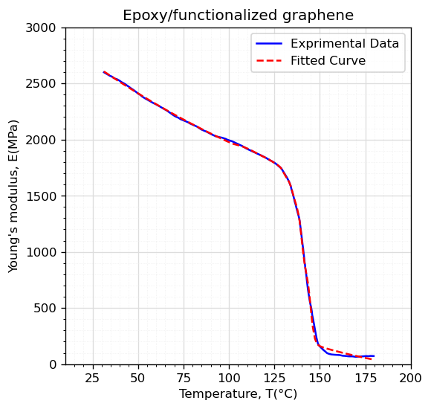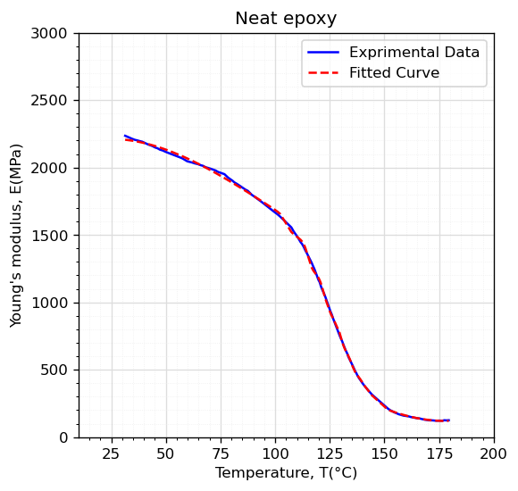

As shown in Table 2, both *R2* and *RMSE* are in excellent agreement (i.e., *R2* of 1, and negligible values for RMSE when compared to the value of young’s modulus).

Figure 1. Comparison of the experimental data for the young’s moduli of neat epoxy, and epoxy/FG reported by Naebe et al. [2] with the fitted curves.

As shown in Figure 1 and Table 2, the results of our modeling are in excellent agreement with the experimental results reported by Naebe et al. [2]. Therefore, the presented regressed model is capable of estimating the elasticity moduli of FG nanocomposites with precision.

|  |  |  |
| --- | --- | --- |
| Table 2. *R2* and *RMSE* values for training and test datasets of the materials | | |
| Material | *R2* | *RMSE* |
| Neat epoxy | 0.9997 | 12.5816 |
| Epoxy/Functionalized graphene | 0.9992 | 13.7280 |

**2.3 The governing equation for thermally affected buckling problem**

In this section, the governing equations needed to solve the buckling problem in presence of temperature gradient of the refined shear deformable beam will be presented. For the sake of brevity, the derivation process will not be expanded in this paper and the thorough procedure can be found in the literature. Finally, the governing equations of motion can be expressed as [7]:

(5)

(4)

(3)

(2)

$$A\frac{∂^{2}u}{{∂x}^{2}}-B\frac{{∂^{3}w}_{b}}{{∂x}^{3}}-B_{s}\frac{{∂^{3}w}_{s}}{{∂x}^{3}}=0$$

$$B\frac{∂^{3}u}{{∂x}^{3}}-D\frac{{∂^{4}w}_{b}}{{∂x}^{4}}-D_{s}\frac{{∂^{4}w}_{s}}{{∂x}^{4}}+k_{w}\left(w_{b}+w_{s}\right)-\left(k_{p}-N^{T}\right)\frac{∂^{2}\left(w_{b}+w_{s}\right)}{{∂x}^{2}}=0$$

(4)

(3)

$$B_{s}\frac{∂^{3}u}{{∂x}^{3}}-D_{s}\frac{{∂^{4}w}_{b}}{{∂x}^{4}}-H_{s}\frac{{∂^{4}w}_{s}}{{∂x}^{4}}+A_{s}\frac{{∂^{2}w}_{s}}{{∂x}^{2}}+k_{w}\left(w_{b}+w_{s}\right)-\left(k_{p}-N^{T}\right)\frac{∂^{2}\left(w_{b}+w_{s}\right)}{{∂x}^{2}}=0$$

Where $u$, $w_{b}$, and $w_{s}$ are the longitudinal displacement, bending, and shear deflections, respectively. The terms $A$, $B$, $B_{s}$, $D$, $D_{s}$, $H_{s}$, and $A_{s}$ are the cross-sectional rigidities which can be defined as mentioned in Ebrahimi and Dabbagh [7]. Also, $k_{w}$ and $k_{p}$ denote the Winkler-Pasternak elastic coefficients of the. Finally, $N^{T}$ stands for the thermal loading produced from the existence of a uniform temperature gradient.

**3. Analytical solution**

Here we used Navier’s solution to extract the critical buckling load of the beam under conditions previously stated. The corresponding boundary conditions for a simply-supported beam can be illustrated as:

(5)

$$w_{b}=w_{s}=0, \frac{∂^{2}w_{b}}{∂x^{2}}=\frac{∂^{2}w_{s}}{∂x^{2}}=0\text{ at }x=0,L$$

Here, we are assuming that the beam’s sides cannot move. Now, the following solution functions can be applied to the displacement fields to satisfy the above-mentioned boundary condition:

(7)

(6)

$$\begin{aligned}&u(x)=\sum_{n=1}^{∞}{ }U_{n}cos⁡\left(\frac{nπx}{L}\right) \\ &w_{b}(x)=\sum_{n=1}^{∞}{ }W_{bn}sin⁡\left(\frac{nπx}{L}\right) \\ &w_{s}(x)=\sum_{n=1}^{∞}{ }W_{sn}sin⁡\left(\frac{nπx}{L}\right)\end{aligned}$$

Where, $U_{n}$, $W_{bn}$, $W_{sn}$ are referred as unknown Fourier coefficients. By inserting the equations (7)-(9) in equations (3)-(5), the following relation can be obtained:

(9)

$${\left[K\right]}_{3×3} \left\{\begin{matrix}U_{n} \\ W_{bn} \\ W_{sn}\end{matrix}\right\}=\left\{0\right\}$$

In which $\left[K\right]$ is the stiffness matrix and $\left\{\begin{matrix}U_{n} \\ W_{bn} \\ W_{sn}\end{matrix}\right\}$ is the displacement vector. To solve for the critical buckling value, the determinant of the stiffness matrix will be set to zero. Once this mathematical operation is done, the critical buckling load of the simply-supported beam can be derived.

**4. Results and discussion**

In this part, a sequence of illustrations will be represented to look into the influence of parameters on the buckling behaviors of beam structures made from neat epoxy, and FGRNC. First off, we validate the presented methodology by comparing the mechanical responses obtained from our modeling with those reported by Yas and Samadi [3] in Table 3. Based on this comparison, it is evident that the method presented in this paper to predict the buckling characteristics of NC beams is valid.

|  |  |  |
| --- | --- | --- |
| Table 3. Comparison of the dimensionless critical buckling load of (C-C) CNTRNC beams ($L/h=15$). | | |
| Volume fraction of CNT, $V_{CNT}^{*}$ | Yas and Samadi [4] | Present |
| 0.12 | 0.213958 | 0.213564 |
| 0.17 | 0.344251 | 0.342843 |
| 0.28 | 0.455602 | 0.460245 |

Now, the effects of FG reinforcement on the fundamental buckling mode (i.e., first mode) of nanocomposite beam will be investigated. In order to better understand the numerical studies, first, the dimensionless form of critical buckling load and foundation coefficients are presented as [5]:

(11)

(10)

$$N_{cr}= N^{b}\frac{L^{2}}{E_{FG }I} , I=\frac{{bh}^{3}}{12}$$

Figure 2 illustrates the change in the buckling loads of the NCs versus the temperature raise. It is worth mentioning that the weight fractions of FG dispersed in the matrix are considered to be 0.1%.

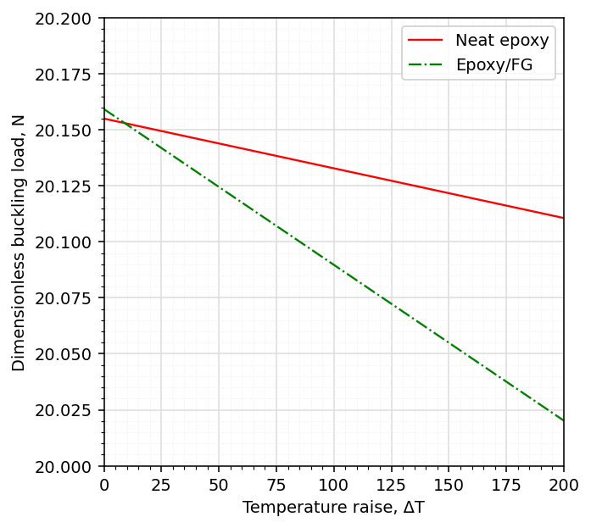

(8)

Figure 2. Variation of the first dimensionless buckling load of beams versus the temperature raise (WFG=0.1%, L/h=15, Kw=100, Kp=10)

It can be realized that with the increase in temperature, the buckling load of the nanocomposite beam decreases. This phenomenon occurs because of the softening impact that the temperature gradient has on the stiffness of the nanocomposite system. Since the stiffness of a material has a direct relation to its buckling load, the buckling load fluctuates with the increment of temperature. Another case revealed by Figure 2 is that near 30 degrees (i.e., room temperature), the buckling load of the FG reinforced nanocomposite beam is more compared to neat epoxy. However, FG reinforced beam has a drastic drop in buckling load as the temperature increases. The main reason for the buckling load’s fluctuation with temperature raise is the negative value of the coefficient of thermal expansion (CTE) for graphene.

As the graphene mixes in the matrix, which has a positive value of CTE, it has a reduction effect on the CTE of the whole mixture. Hence, the lower weight fraction of graphene in the composite results in higher CTE compared to the high concentration of graphene reinforcement.

Figure 3 is depicted with the goal of studying the impact of both slenderness ratio of the beam and temperature gradients on the stability behaviors of FGRNC beam. Based on this figure, with the rise of slenderness ratio of the beam, the dimensionless buckling load declines non-linearly. This behavior can be explained with the more flexible geometry of the beam types that comes along as the slenderness ratio rises. Ensuing, stiffness, which has an inverse relationship with flexibility, decreases gradually. Hence, as discussed earlier, the value of buckling load abates with the reduction of stiffness.

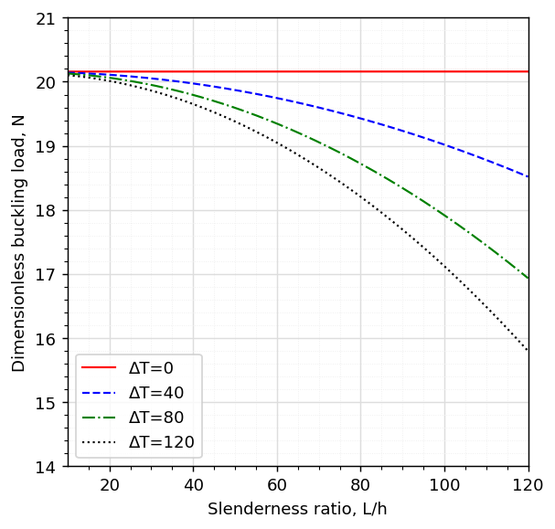

Figure 3. Variation of the first dimensionless buckling load of nanocomposite beam versus the slenderness ratio (WFG=0.1%, Kw=100, Kp=10)

However, this downturn can be much harsher as the temperature gradient increments. Moreover, if the slenderness ratio of the nanocomposite beam reaches its critical value, the buckling load can even go as low as zero (i.e., the neutral stable state).

**5. Conclusion**

This study was motivated to present a continuous analytical function to accurately estimate the young’s moduli of FG reinforced nanocomposites at any desired temperature. Ensuing, the developed model was put into work to determine the thermo-elastic stability of nanocomposite beams. It was also realized that the beams become more flexible when exposed to higher values of temperature raise. In conclusion, the FGRNC was shown to have a greater elastic modulus compared to neat epoxy, However, the temperature raise had a more drastic effect on the FGNRC because of the negative value of CTE. Hence, this research recommends implementing lesser weight fractions of graphene reinforcements when the structure is subjected to immense thermal loading.

**References**

[1] L.-C. Tang, Y.-J. Wan, D. Yan, Y.-B. Pei, L. Zhao, Y.-B. Li, L.-B. Wu, J.-X. Jiang, G.-Q. Lai, The effect of graphene dispersion on the mechanical properties of graphene/epoxy composites, Carbon 60 (2013) 16-27.

[2] M. Naebe, J. Wang, A. Amini, H. Khayyam, N. Hameed, L.H. Li, Y. Chen, B. Fox, Mechanical property and structure of covalent functionalised graphene/epoxy nanocomposites, Scientific reports 4(1) (2014) 1-7.

[3] M. Yas, N. Samadi, Free vibrations and buckling analysis of carbon nanotube-reinforced composite Timoshenko beams on elastic foundation, International Journal of Pressure Vessels and Piping 98 (2012) 119-128.

[4] F. Ebrahimi, A. Dabbagh, Ö. Civalek, Vibration analysis of magnetically affected graphene oxide-reinforced nanocomposite beams, Journal of Vibration and Control 25(23-24) (2019) 2837-2849.

[5] M.A. Amani, F. Ebrahimi, A. Dabbagh, A. Rastgoo, M.M. Nasiri, A machine learning-based model for the estimation of the temperature-dependent moduli of graphene oxide reinforced nanocomposites and its application in a thermally affected buckling analysis, Engineering with Computers 37(3) (2021) 2245-2255.

[6] S. Zhao, Y. Zhang, D. Chen, J. Yang, S. Kitipornchai, Enhanced thermal buckling resistance of folded graphene reinforced nanocomposites with negative thermal expansion: From atomistic study to continuum mechanics modelling, Composite Structures 279 (2022) 114872.

[7] F. Ebrahimi, A. Dabbagh, On thermo-mechanical vibration analysis of multi-scale hybrid composite beams, Journal of Vibration and Control 25(4) (2019) 933-945.