**Hydrogenation reduction of dyes by SBA-Pr-3N@Pd (SBA-Pr-3AP@Pd) complex**

**Fatemeh Mohajer,1,* Ghodsi Mohammadi Ziarani,2,* Alireza Badiei3**

|  |  |
| --- | --- |
| 1Post-doc researcher, Department of Chemistry, Faculty of Physics and Chemistry, Alzahra University, Tehran, Iran | f.mohajer@alzahra.ac.ir |
| 2Professor, Department of Chemistry, Faculty of Physics and Chemistry, Alzahra University, Tehran, Iran | gmohammadi@alzahra.ac.ir |
| 3Professor, School of Chemistry, College of Science, University of Tehran, Iran | abadiei@ut.ac.ir |

**Abstract**

SBA-Pr-3N@Pd was investigated as catalysts for the degradation of natural, synthetic organic dyes. SBA-Pr-3N@Pd was used for the catalytic hydrogenation of organic dyes using sodium borohydride (NaBH4) as a reducing agent. It displayed high catalytic efficiency and required a short reaction time with excellent recyclability and a simple regeneration process. The materials may open new avenues for an efficient catalyst for water remediation.

**Keywords:** Decorated mesoporous silica, Heterogeneous nanoporous catalyst, SBA-Pr-3N@Pd, Dyes and pollutants degradation.

**هیدروژن دار کردن ترکیبات رنگی بوسیله** **SBA-Pr-3N@Pd**

فاطمه مهاجر1*، قدسی محمدی زیارانی2، علیرضا بدیعی3

|  |  |
| --- | --- |
| 1*محقق پسادکتری، دانشگاه الزهرا | f.mohajer@alzahra.ac.ir |
| 2عضو هیات علمی دانشگاه الزهرا | gmohammadi@alzahra.ac.ir |
| 3 عضو هیات علمی دانشگاه تهران | abadiei@ut.ac.ir |

# چكيده

SBA-Pr-3N@Pd به عنوان کاتالیزور برای تخریب رنگ های آلی طبیعی و مصنوعی مورد بررسی قرار گرفت. SBA-Pr-3N@Pd برای هیدروژناسیون کاتالیزوری رنگهای آلی با استفاده از بوروهیدرید سدیم (NaBH4) به عنوان یک عامل احیا کننده استفاده شد. راندمان کاتالیزوری بالایی را نشان داد و به زمان واکنش کوتاهی با قابلیت بازیافت عالی و فرآیند بازسازی ساده نیاز داشت. این مواد ممکن است راه های جدیدی را برای یک کاتالیزور کارآمد برای تصفیه آب باز کنند.

**کليدواژه­ها:** سیلیس مزو متخلخل تزئین شده، کاتالیزور نانومتخلخل ناهمگن، SBA-Pr-3N@Pd، تخریب رنگ‌ها و آلاینده‌

**Introduction**

Clean water scarcity is growing due to the decreasing water, pollution, rapid  
development of industries, and growing populations.1 According to The United  
Nations World Water Development Report 2019, over 2 billion people live in  
countries experiencing high water stress due to several reasons including pollutions.2  
Water and energy shortages are highly important issues, as these days billion of people could not access safe water. Over two billion people lack access to adequate sanitation, resulting in approximately two million deaths each year from waterborne diseases transmitted through contaminated water sources.3

In this regard, reducing nitroaromatic compounds with heterogeneous catalysts and alternative hydrogen sources such as H3NBH3, NaBH4, and NH2NH2 results in the production of aromatic amines that are less toxic, biodegradable, and can be used as intermediates in the manufacture of pharmaceutical and industrial compounds.4, 5 6Immobilization of catalytic metals on solid supports such as activated carbon7, polymers8, alumina9, zeolites10, and TiO211 may significantly enhance catalyst availability and recovery. Additionally, biopolymers such as chitosan have received significant attention in recent years due to their numerous benefits, including versatility, biocompatibility, biodegradability, nontoxicity, high stability, low cost, as well as environmental friendliness, high loading capacity, and multifunctionality.12

Selective reduction of nitro compounds into amines is one of the most important chemical reactions in synthetic organic chemistry. 13 14Amines with an annual production of more than 4 million metric tons15 have been widely used for the production of bulk and fine chemicals, such as dyes, agrochemicals, pharmaceuticals, pesticides, and polymers.16 In the past, a noncatalytic process was used for the reduction of nitro compounds using stoichiometric reducing agents17 an approach that demonstrated some drawbacks, such as the release of wastes and the high cost of reducing agents. Therefore, considerable attention has shifted to the catalytic reduction of nitro compounds into amines because of the compatibility of environmentally friendly catalytic methods with industrial processes. 18

The catalytic reduction of nitro compounds with hydrogen or hydrogen donors has been mainly performed over noble metal catalysts. .19, 20 Unfortunately, most catalysts do not meet the dual requirements of activity and selectivity.21

Herein, SBA-Pr-3N@Pd complex were synthesized. The materials were characterized using X-ray diffraction (XRD), Fourier transforms infrared (FT-IR), electron microscope (scanning SEM), and transmission),22 thermogravimetric analysis (TGA), atomic absorbance flame (AAF), and nitrogen adsorption-desorption isotherm. The materials were applied for organic synthetic ana natural dye degradation, reduction reaction using catalytic hydrogenation. It was proved high performance compared to the previously reported materials including metallic, metal oxides nanoparticles and composites.

**Experimental**

**Materials**

Preparation of SBA-15-Pr-3AP@Pdand studying its catalytic activity in the Suzuki cross-coupling reaction included (3-aminopropyl)triethoxysilane, EtOH, distilled water, *n*-Hexane, ethyl acetate, K2CO3, toluene (Merck), Pd, Et3N, 2,4,6-triamino pyrimidine, tetraethylorthosilicate (TEOS), triethylamine, phenylboronic acid and various aryl halides which purchased from Merck and Sigma Aldrich and used without more purification.

**Instruments**

BELSORP-miniI recorded N2 adsorption-desorption isotherms instrument at liquid nitrogen temperature (-196 °C). The degassing procedure for the sample has been done at 100 °C before the application. The Brunauer-Emmett-Teller (BET) and Barrett-Joyner-Halenda (BJH) equations have done on sorption data by BELSORP analysis software to define the physical properties of materials such as the pore diameter, pore-volume, specific surface area, and pore size spreading. Thermogravimetric analyses (TGA) were accomplished by a TGA Q50 V6.3 Build 189 device at room temperature to 1000 °C with a ramp rate of 10 °C min-1 in the air. FT-IR spectra were obtained in KBr disks on a RAYLEIGH WQF-510A FT-IR spectrometer in 600–4000 cm−1 regions.

**Synthesis of SBA-15- Pr-Cl**

In this process, SBA-15 was prepared according to the literature.23 The synthesized SBA-15 (1 g) was dispersed in dry toluene (50 mL) and stirred for 1 h at room temperature to obtain a homogenous media. Then (3-chloropropyl)triethoxysilane (2.4 g) (10 mmol) was added to the stirring suspension and refluxed for 24 h. The product was filtered and washed with an excess amount of toluene and dried at room temperature.

**Synthesis of SBA-Pr-3AP**

The 2,4,6-triaminpyrimidine compound (0.25 g) was added to the dispersed SBA-Pr-Cl (1 g) in EtOH, and Et3N refluxed for 24 h. The obtained white powder was filtered and washed with excess EtOH, to remove any residual organosilane by soxhlation method using EtOH as solvent over a 24 h to obtain SBA-Pr-3AP as the white powder, which was dried at ambient temperature.

**Immobilization of Pd(II) Ions on Surface of SBA-Pr-3N@Pd**

SBA-Pr-3AP (1.0 g) and palladium chloride (0.2 g) in EtOH (40 mL) was refluxed for 24 h. The dark grey powder as a resulting solid was filtered, washed with acetone, and dried in vacuum at 80 ˚C for 2 h to give SBA-Pr-3N@Pd. According to the AAS, 25.91 wt % of palladium was precipitated on the synthesized catalyst. Also, there is no Pd in the reaction solution until the 7th run.

**Characterization and Synthesis of Catalyst**

In the first step, SBA-15 reacted with (3-chloropropyl)triethoxysilane in dry toluene under reflux condition to form SBA-Pr-Cl, which reacted with the 2,4,6-triamino pyrimidine in EtOH using Et3N as a base under reflux condition to give SBA-Pr-3AP. In the last step, the Pd ions were immobilized on the nano-heterogeneous surface catalyst of SBA-Pr-3AP (Scheme 1), which was characterized by XRD, SEM, FT-IR, N2 adsorption-desorption, EDX, and TGA analysis.



**Scheme 1**. The synthetic procedure for the preparation of SBA-Pr-3N@Pd catalyst

**FT-IR analysis**

To characterize and confirm the functionalized groups on the catalyst, FT-IR spectroscopy was applied, as shown in Fig. 1 for (a) SBA-15 (b) SBA-Pr-Cl, (c) SBA-Pr-3AP and (d) SBA-Pr-3N@Pd. The bands at 800, 960, and 1100 cm-1, are existing in all spectra, which are related to Si-O-Si symmetrical stretching vibrations, Si-OH symmetrical stretching vibrations, and unsymmetrical stretching vibrations of Si-O-Si spectroscopy, respectively. In the SBA-Pr-Cl (b), SBA-Pr-3AP (c), and SBA-Pr-3N@Pd (d), the peaks appearing at 2852 and 2956 cm -1 are the representative of aliphatic CH2 groups, which demonstrates the propyl group into the pore walls of SBA-15. The peak around 600-800 cm-1 shows Cl group in the second spectrum. The stretching vibration of the carbon-carbon double bond in aromatic ring appeared at 1554 cm−1, and the peaks of 1454 cm-1 displayed stretching vibrations of the C=N group for the spectra of (c) and (d). The band at 1648 cm-1 is due to the imine bond of the aromatic ring and its stretching vibrations displayed at 705 cm-1. Moreover, the band at 578 cm−1 in the spectrum of SBA-Pr-3N@Pd is assigned to stretching of Pd-N 24. These results showed that the synthesized SBA-15 was effectively functionalized with Pd species and obtained the final catalyst SBA-Pr-3N@Pd.

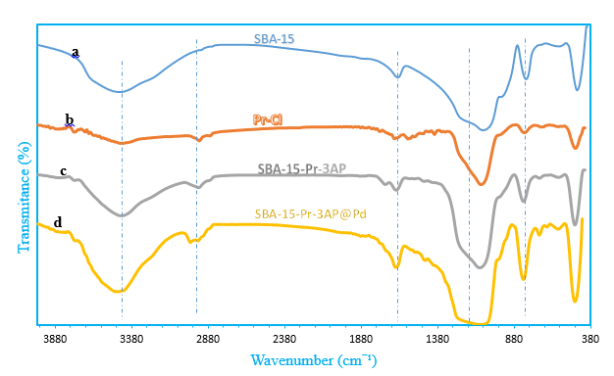

**Fig 1.** FT-IR spectra of (a) SBA-15, (b) SBA Pr-Cl (c) SBA-Pr-3AP (d) SBA-Pr-3N@Pd

**EDX analysis**

The EDX spectrum in Fig. 2 explains the presence of the elements C, N, O, Si, and Pd in SBA-Pr-3AP@Pd. The palladium peak displays the immobilization of the Pd nanoparticles on the surface of SBA-Pr-3N@Pd.

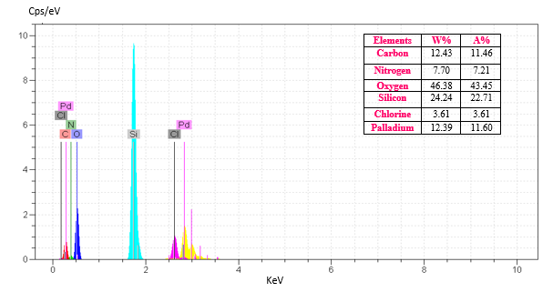

**Fig 2.** EDX Spectrum of SBA-Pr-3N@Pd

**BET analysis**

The nitrogen adsorption-desorption isotherms and the BJH pore size distribution (based on the adsorption branch of the isotherms) for all samples SBA-15, SBA-Pr-3AP, and SBA-Pr-3N@Pd are shown in Fig. 3,4. Type IV characterizes the isotherms with an H1-type hysteresis loop defined by IUPAC, demonstrating the well-ordered mesoporous arrangement of SBA-15. Table 1 presents the results for three structural parameters of the samples, including specific surface area (BET method), total pore volume, and pore diameter (BJH method). Successful incorporation of functional organic materials into mesoporous SBA‐15 silica pores and the inclusion of Pd into this structure shifted the pore size to a smaller value and led to diminishing in pore volume and surface area.

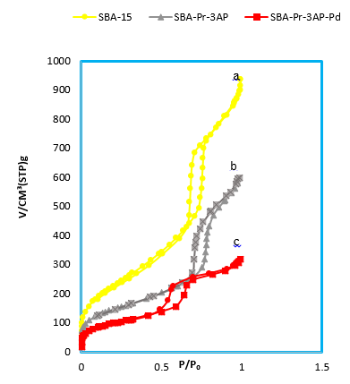

**Fig 3.** N2 adsorption–desorption isotherms of (a) SBA-15, (b) SBA-Pr-3AP, (c) SBA-Pr-3N@Pd

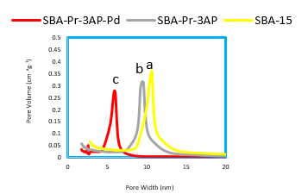

**Fig 4.** BJH pore size distribution curves of (a) SBA-15, (b) SBA-Pr-3AP, (c) SBA-Pr-3AP@Pd

**Table 1.** Texture properties of (a) SBA-15, (b) SBA Pr-Cl (c) SBA-Pr-3AP (d) SBA-Pr-3AP@Pd

|  |  |  |  |  |  |  |
| --- | --- | --- | --- | --- | --- | --- |
| Entry | Catalyst | aSBET (m2g–1) | aV (cm3g–1) | | aDBJH (nm) | |
| 1 | SBA-15 | 898 | | 0.99 | | 9.9 |
| 3 | SBA-Pr-3AP | 521 | | 0.79 | | 7.4 |
| 4 | SBA-Pr-3AP@Pd | 351 | | 0.49 | | 5.2 |

aSBET is a specific surface area, V total pore volume, and DBJH average pore diameter

**XRD analysis**

Low‐angle XRD patterns of SBA-15 and SBA-Pr-3AP@Pd catalyst are shown in Fig 5. SBA-15 has a strong diffraction reflection (100) and two small diffraction reflections (110) and (200) due to hexagonal symmetry and its long‐range ordering structure 25. The SBA-Pr-3AP@Pd marks a decrease in the overall intensity of the (100), (110), and (200), which might be related to the organic compounds and Pd attached particles.

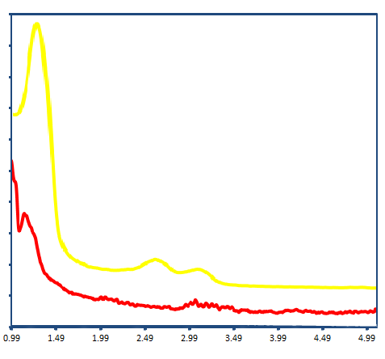

a

2Ө (°)

a

b

**Fig 5**. Low-angle XRD patterns of (a) SBA-15, (b) SBA-Pr-3N@Pd

There is a flat pattern in the wide-angle XRD diffraction pattern, which related to the pure SBA-15 and SBA-Pr-3AP. Two peaks around 40°, 45° could be attributed respectively to the (111), (200), which related to the metallic Pd(II), the fresh SBA-Pr-3AP@Pd catalyst diffractogram. It was proved that the Pd(II) was immobilized on the SBA-Pr-3AP (Fig 6).

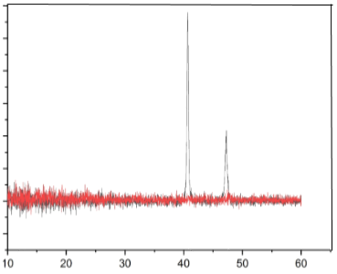

2ϴ (degree)

**(a): SBA-15-Pr-3AP**

**(b): SBA-15-Pr-3AP@Pd**

**Fig 6**. The wide angle XRD patterns of (a) SBA-Pr-3AP, (b) SBA-Pr-3AP@Pd

**SEM analysis**

A typical scanning electronic microscopy (SEM) images of SBA-15 (a), SBA-Pr-3AP (b), and SBA-Pr-3AP@Pd (c), was not changed as shown in Fig 7. In this case, the arrays of two‐dimensional hexagonal mesoporous SBA‐15 and the attachment of organic components inside the pore channels of SBA‐15 silica has no distinct influence on the morphology of composition

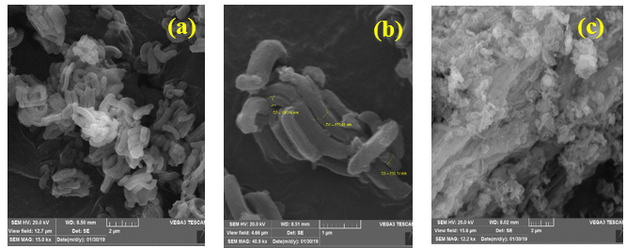

**Fig 7**. SEM images of (a) SBA-Pr-Cl, (b) SBA-Pr-3AP, (c) SBA-Pr-3AP@Pd

To approve the synthesized SBA-Pr-3AP@Pd catalyst nature, its TEM image was recorded after reaction completion, which showed the presence of Pd nanoparticles, as shown in Fig 8.

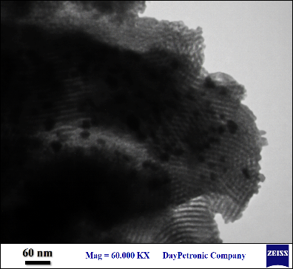

**Fig 8**. TEM images SBA-Pr-3AP@Pd

**General procedure for catalytic degradation of synthetic and natural organic dyes**

A typical catalytic reaction was conducted by preparing 20 ml of an aqueous solution of the organic dyes followed by the addition of 2 mg of NaBH4 and 0.01 g of SBA-Pr-3AP@Pd nanocatalyst. The reaction was monitored using UV–vis absorption spectroscopy immediately after adding a nanocatalyst at room temperature.



**Reusability process of the SBA-Pr-3N@Pd nanocatalyst**

Following completion of the reduction reaction, the **SBA-Pr-3N@Pd** nanocatalyst was separated and, washed with water and ethanol, and dried. The recycled catalyst was then reused in reduction reaction.

**Conclusions**

SBA-Pr-3N@Pd have been successfully synthesized and characterized. The materials show high catalytic performance for the reduction and degradation of organic dyes. The materials provide high efficiency, short reaction time, and can be effective with low catalyst loading.

**Acknowledgments**  
We appreciate the partial financial assistance provided by Alzahra University’s research council.

**References**

1 J. R. Werber, C. O. Osuji, M. Elimelech, *Nature Reviews Materials* **2016**, *1*, 1-15.

2 Z. Zhongming, L. Wei, **2019**.

3 D. J. Miller, D. R. Dreyer, C. W. Bielawski, D. R. Paul, B. D. Freeman, *Angewandte Chemie International Edition* **2017**, *56*, 4662-4711.

4 Y. Zhu, W. D. Wang, X. Sun, M. Fan, X. Hu, Z. Dong, *ACS Applied Materials & Interfaces* **2020**, *12*, 7285-7294.

5 M. Yuan, Y. Long, J. Yang, X. Hu, D. Xu, Y. Zhu, Z. Dong, *ChemSusChem* **2018**, *11*, 4156-4165.

6 Q. Song, D. Xu, W. D. Wang, J. Fang, X. Sun, F. Li, B. Li, J. Kou, H. Zhu, Z. Dong, *Journal of Catalysis* **2022**, *406*, 19-27.

7 Q. Shi, G. Diao, *Electrochimica acta* **2011**, *58*, 399-405.

8 C. Yuan, Y. Xu, W. Luo, B. Zeng, W. Qiu, J. Liu, H. Huang, L. Dai, *Nanotechnology* **2012**, *23*, 175301.

9 F. Cardenas-Lizana, S. Gómez-Quero, N. Perret, M. A. Keane, *Catalysis Science & Technology* **2011**, *1*, 652-661.

10 P. Kosobucki, M. Kruk, B. Buszewski, *Bioresource technology* **2008**, *99*, 5972-5976.

11 A. Yoshida, Y. Mori, T. Ikeda, K. Azemoto, S. Naito, *Catalysis today* **2013**, *203*, 153-157.

12 F. Rafiee, *Current Organic Chemistry* **2019**, *23*, 390-408.

13 S. Nishimura, *Handbook of heterogeneous catalytic hydrogenation for organic synthesis*. Editor, Wiley New York, **2001**.

14 J. P. Adams, J. R. Paterson, *Journal of the Chemical Society, Perkin Transactions 1* **2000**, 3695-3705.

15 Q. Yang, Y.-Z. Chen, Z. U. Wang, Q. Xu, H.-L. Jiang, *Chemical Communications* **2015**, *51*, 10419-10422.

16 R. Downing, P. Kunkeler, H. Van Bekkum, *Catalysis today* **1997**, *37*, 121-136.

17 N. Zinin, *Journal für Praktische Chemie* **1842**, *27*, 140-153.

18 H. K. Kadam, S. G. Tilve, *RSC advances* **2015**, *5*, 83391-83407.

19 P. Lara, K. Philippot, *Catalysis Science & Technology* **2014**, *4*, 2445-2465.

20 S. Zhang, C.-R. Chang, Z.-Q. Huang, J. Li, Z. Wu, Y. Ma, Z. Zhang, Y. Wang, Y. Qu, *Journal of the American Chemical Society* **2016**, *138*, 2629-2637.

21 U. Siegrist, P. Baumeister, H.-U. Blaser, M. Studer, *CHEMICAL INDUSTRIES-NEW YORK-MARCEL DEKKER-* **1998**, 207-220.

22 T. Deblonde, C. Cossu-Leguille, P. Hartemann, *International journal of hygiene and environmental health* **2011**, *214*, 442-448.

23 D. Zhao, J. Feng, Q. Huo, N. Melosh, G. H. Fredrickson, B. F. Chmelka, G. D. Stucky, *J. Sci.* **1998**, *279*, 548-552.

24 K. Mukhopadhyay, B. R. Sarkar, R. V. Chaudhari, *J. Am. Chem. Soc.* **2002**, *124*, 9692-9693.

25 H. Vojoudi, A. Badiei, S. Bahar, G. Mohammadi Ziarani, F. Faridbod, M. R. Ganjali, *Powder Technol.* **2017**, *319*, 271-278 <https://doi.org/10.1016/j.powtec.2017.06.028>.