**In-situ Synthesis of Nitrogen-doped MoS2 Quantum Dots using Pulsed Laser Ablation in Liquid Nitrogen Medium**

**Fatemeh Shahi 1, Parviz Parvin 2*,** **Seyedeh Zahra Mortazavi 3, Ali Reyhani 3, Mohtada Sadrzadeh4 and Ali Moafi 5**

|  |  |
| --- | --- |
| 1PhD Candidate, Energy Engineering and Physics Department, Amirkabir University of Technology | f.shahi.3035@aut.ac.ir |
| 2*Energy Engineering and Physics Department, Amirkabir University of Technology | Parvin@aut.ac.ir |
| 3Faculty of Science, Department of Physics, Imam Khomeini International University | z.mortazavi@sci.ikiu.ac.ir  reyhani@sci.ikiu.ac.ir |
| 4Mechanical Engineering Department, University of Alberta | sadrzade@ualberta.ca |
| 5Energy Engineering and Physics Department, Amirkabir University of Technology | ali.moafi@aut.ac.ir |

**Abstract**

Nitrogen doped MoS2 quantum dots (N- MoS2 QDs) are fabricated by pulsed laser ablation (PLA) process in liquid nitrogen (LN2). In fact, not only LN2 facilitates the condensation of the laser-induced plasma plume to produce MoS2 QDs and some by-products such as nanosheet, but also provides an optimum condition for N-doped MoS2 synthesis as a p-type semiconductor. The structural and optical properties synthesized products are investigated using transmission electron microscopy (TEM),UV−vis−near infraredabsorption spectroscopy and photoluminescence Spectroscopy techniques. The TEM image shows formation of MoS2 QDs. The Tuck plot is observed for a direct band-gap MoS2 QDs (4.18 eV). Thus, PLA provides a single-stage way to clean and green synthesis the MoS2 QDs suspension without a need of high vacuum devices and additional chemical components. Moreover, doping provides an advantage to engineering the optical and electrical characteristics of MoS2.

**Keywords:** MoS2 quantum dots, Pulsed laser ablation, Liquid nitrogen, Nitrogen doping.

**سنتز درجا نقاط کوانتومی MoS2 آلاییده‌شده با نیتروژن با استفاده از روشی کندکی لیزری در محیط نیتروژن مایع**

فاطمه شاهی1،پرویز پروین2*، سیده زهرا مرتضوی3، علی ریحانی3، مهتدی صدرزاده4 و علی معافی5

|  |  |
| --- | --- |
| 1دانشجوی دكتري دانشکده مهندسی انرژی و فیزیک دانشگاه صنعتی امیرکبیر | f.shahi.3035@aut.ac.ir |
| 2*عضو هیات علمی دانشکده مهندسی انرژی و فیزیک دانشگاه صنعتی | Parvin@aut.ac.ir |
| 3هیات علمی دانشکده فیزیک دانشگاه بین المللی امام خمینی قزوین | z.mortazavi@sci.ikiu.ac.ir  reyhani@sci.ikiu.ac.ir |
| 4 هیات علمی دانشکده مهندسی مکانیک دانشگاه آلبرتا | sadrzade@ualberta.ca |
| 4 استاد پژوهشی دانشکده مهندسی انرژی و فیزیک دانشگاه صنعتی | ali.moafi@aut.ac.ir |

# چكيده

نقاط کوانتومی MoS2 دوپ شده با نیتروژن توسط روش کندگی لیزر پالسی در محیط نیتروژن مایع تولید شده است. در واقع، نیتروژن مایع نه تنها چگالش پلوم پلاسمای القایی لیزری را برای تولید QD های MoS2 و برخی محصولات جانبی مانند نانوصفحات تسهیل می کند، بلکه شرایط بهینه‌ای را برای سنتز MoS2 آلاییده‌شده با نیتروژن به عنوان یک نیمه‌هادی نوع p فراهم می‌کند. ویژگی‌های ساختاری و نوری محصولات سنتزشده با استفاده از میکروسکوپ الکترونی عبوری (TEM)، طیف‌سنجی جذبی و طیف‌سنجی فوتولومینسانس بررسی شده است. تصویر TEM شکل‌گیری QD های MoS2 را نشان می‌دهد. نمودارTuck ، QDsهای MoS2 با شکاف مستقیم (4.18 eV) را نشان می‌دهد. بنابراین،PLA یک روش تک مرحله‌ای و سبز برای تولید MoS2 QDs بدون نیاز به خلاء بالا و ترکیبات شیمیایی خطرناک ارائه می‌کند. علاوه‌بر‌این، آلاییده‌کردن مزیتی برای مهندسی ویژگی‌های نوری و الکتریکی MoS2 فراهم می‌کند.

**Introduction**

MoS2 quantum dots (QDs), a novel class of QDs that resemble graphite, have garnered significant interest in both academic and industrial research domains due to their remarkable optical and electrical properties. The approaches widely used for the synthesis of mono- and few-layer MoS2 nanomaterials can be classified as top-down including mechanical exfoliation [1, 2], chemical exfoliation [3-5]and laser thinning technique [6]. The bottom-up methods consist of chemical vapor deposition (CVD) [7-11] and pulsed laser deposition (PLD) [12-14]. In the CVD method, a large scale deposition of MoS2 takes about more than 24 hours to complete indicating time-consuming [15]. Therefore, the exfoliation and intercalation techniques may not be suitable for industrial applications owning to solvent dangerous precursors [14]. The cost of making nanomaterials by PLD method is relatively high because of the use of vacuum chambers and gas handling systems too [16].PLA of solid targets is promising and emerging method to obtain stable suspensions of various nanostructures in a wide range of liquids. Compared to other methods; PLA, especially in liquids, is a versatile, single-step, simple and economic procedure method of generating colloidal, highly pure and agent-free which can be applied at industrial scales due to intrinsically environmental friendly as well [17-19].

There are few reports on the synthesis of MoS2 using the PLA method in liquid media, which are tabulated alongside the their specifications in Table 1. Yin et al. proposed a method to synthesis MoS2 QDs to promote apoptosis of the cancer cells according to photothermal effects [20]. Baldovı´ et al obtained MoS2 quantum dots (QDs) in colloidal suspensions at laser ablation 532 nm with pulse duration 7 ns, 50 mJ/pulse of commercial MoS2 particles in acetonitrile and owing to their photocatalytic activity applied in H2 generation[21]. Mortazavi et al. reported a novel, fast and straightforward technique for 2D material exfoliation using Q-switched Nd:YAG laser shots over the target in LN2 [22]. On the other hand, the non-metal dopants (N, P, O,etc.) with small atomic sizes replace the S atoms in MoS2 to create p-type semiconductors. The MoS2 doping improves their electronic properties, intrinsic conductivity and the catalytic efficiency [23-27]. Recently, we obtained the N-MoS2 nanosheets using the PLA method in a LN2 medium and demonstrated that these are P-type semiconductors [28]. Doping N into MoS2 can increase the number of active sites through activating the hydrogen evolution reaction (HER) activity of S-edge and improving the activity of Mo-edge and enhance the conductivity of MoS2 basal plane. MoS2 QDs (with nanometer size and few layers) possess much higher density of edges than MoS2 nanosheets (with micrometer size) in same weight [23, 29].

Here, the synthesis of N-MoS2 QDs is investigated based on Q-switched Nd:YAG laser ablation of the bulk material in LN2 medium.

Table 1: Specifications of synthesized MoS2 QDs via PLA in different media.

|  |  |  |  |  |  |
| --- | --- | --- | --- | --- | --- |
| Laser | Medium | Sizes | UV-Vis peak [nm] | PL peak [nm] | Ref. |
| 355, 532 and 1064 nm (6-7 ns) | Water | 2–30 nm | 209.8 and 211.4 | 553-563 | [30] |
| 532 nm - 7 ns | Acetonitrile | 3–6 layers  5 to 20 nm | 450 | 440 to 530 | [21] |
| 800 nm - 50 fs | Water | 1–120 nm  1-5 nm | λ < 300 | 340 to 450 | [31] |
| 800 nm - 150 fs | Diethylamine | 1.8 nm | 275 | ~420 | [32] |
| 1026 nm - 170 fs | water | - | - | 448 nm | [33] |

**Experimental Section/Methods**

The target is prepared by spark plasma sintering (SPS) of MoS2 powder (Aldrich chemical, powder, < 2 µm, 99%) in the form of a 30 mm dia disk at 20 MPa. MoS2 QDs are synthesized by the ablation in LN2 (–195.8 ) using a Q-switched Nd:YAG laser. The laser operates at 1064 nm with 10 ns pulse duration at 5 Hz repetition rate corresponding to 15 mJ/shot and the laser fluence of 1.5 J cm-2. Laser ablation is usually carried out for an exposure time of 10 min (3000 shots). Figure 1 illustrates the experimental setup schematic of the synthesis of MoS2 in LN2. At first, the MoS2 bulk target is placed at the bottom of the irradiation a cryostat. After creating the vacuum in chamber, the cryostat is filled with LN2 as cryogenics media for laser ablation. The LN2 injection into cell continually goes on as long as a thermal steady state condition is achieved. The laser beam is focused through a plano-convex lens with focal length of 32 mm at the target. The elimination of combustion materials and LN2 vapors is carried out via the ventilation window. After laser exposure, the residual LN2 is evaporated at the room temperature. Subsequently, DI water-ethanol mixture is added to the cell to make a suspension for the MoS2 collection.

A colloidal suspension of highly homogeneous few layer MoS2 QDs is prepared from MoS2 target through PLA method followed by extensive centrifugation. MoS2 QDs are separated from the suspension through centrifugation (Hettich universal 320)for 500 rpm for 30 minutes. The supernatant is re-centrifuged with 1000 rpm for 1 hour based on their weight difference to obtain a transparent light yellow supernatant suspension. Finally, a colloidal suspension of highly homogeneous MoS2 QDs is prepared. The supernatant includes a dominant population of QDs.

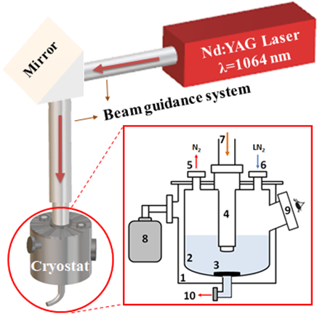

Figure 1: Schematic of the experimental setup of homemade cryostat irradiation chamber for MoS2 synthesis in LN2 and color appearance of products.(a) 1- vacuum chamber, 2- LN2 reservoir, 3- MoS2 target mount, 4- beam delivery section, 5- ventilation outlet (N2 evaporator), 6- LN2 inlet, 7- laser irradiation window, 8- rotary pump, 9- monitoring window and 10- product outlet.

**Characterization**

The morphology and structure of end products are investigated using transmission electron microscopy (TEM, Philips CM30 microscope operating with an acceleration voltage of 150-200 kV). The obtained suspension is drop-casted onto copper (a carbon-coated) TEM grid. The optical properties of synthesized MoS2 QDs are obtained with the UV−visible absorption (spectrophotometer operating in the 200−1100 nm wavelength range with a pulsed Xenon light source). It is equipped with a dual silicon photodiode detector coupled with the spectrometer having 1.5 nm resolution. The photoluminescence (PL) spectrum are measured with a spectral resolution of 1 nm. This utilizes a coherent pulsed Xenon flash lamp ranging 200-1100 nm equipped with a photomultiplier array detector.

**Results and discussion**

MoS2 QDs are synthesized by laser-induced intercalation and exfoliation of MoS2 target in LN2 medium using PLA after centrifugation. Figure 2 shows TEM image of MoS2 QDs generated by Q-switched Nd:YAG laser in LN2 with 5 Hz repetition rate and pulse energy 15 mJ. The nanostructure of the sample is QDs. It is understood that the majority of MoS2 QDs are arranged a chain of QDs.

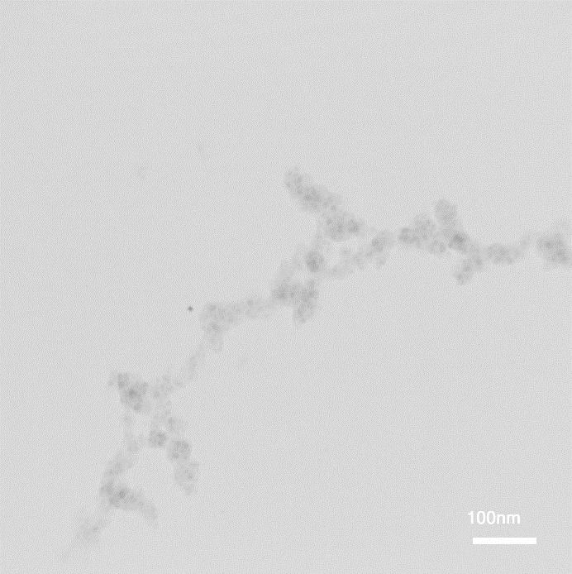

Figure 2: TEM image of MoS2 QDs generated by Q-switched Nd:YAG laser during cryogenic PLA synthesis process.

**Error! Reference source not found.** illustrates the normalized optical absorption spectrum of MoS2 QDs at 10 min. In the MoS2 nanosheet, A and B excitonic peaks are located at 627 nm and 677 nm, respectively [28]. The peak positions of the absorption spectra associated with the direct excitonic transitions can change by varying the number of layers. Furthermore, C and D broad peaks lie around 457 nm and 402 nm respectively, attributing to the direct transition from the deep valence to the conduction bands [28]. In the supernatant, four distinctive excitonic peaks lucidly disappear. Instead, a couple of peaks are observed in the near-UV region (λ < 300 nm), related to the excitonic characteristic of N-MoS2 QDs [29, 31].

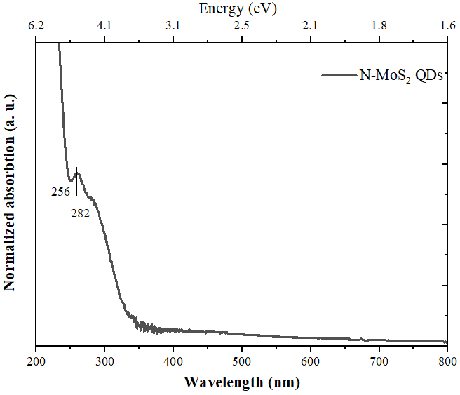

Figure 3: Absorption spectrum of MoS2 QDs generated by Q-switched Nd:YAG laser during cryogenic PLA synthesis process.

The optical absorption coefficient (α) is calculated as below equation [34] according to Beer-Lambert law:

|  |  |
| --- | --- |
| $$α=2.303 \frac{A}{d}$$ | (1) |

where A is the absorbance $A=\log\left(\frac{I_{0}}{I}\right)$ value at the specific wavelength and d is the thickness of the sample, which is taken to be 1 cm, equal to the thickness of quartz cuvette. The applying the UV-Vis data, the optical band gap energy of the MoS2 QDs can be estimated by using Tauc equation as follows [35, 36]:

|  |  |
| --- | --- |
| $${\left(αhυ\right)}^{\frac{1}{n}}=B\left(hυ-E_{g}\right)$$ | (2) |

where α, *h*ν and *E*g are a constant, the absorption coefficient, the photon energy of the incident light and the optical band gap energy. B is a constant which depends on the type of transition. Depending on the type of transition, n is 1/2, 1, 3/2 and 2 for allowed direct, allowed indirect, forbidden direct and forbidden indirect, respectively. Here, it considers the allowed direct transition with n=1/2. In a direct gap, photon emission takes place because the electron must pass through an intermediate state without transferring momentum to the crystal lattice.

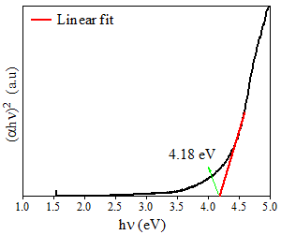

Figure 4: The optical band gap energy (by Tauc method) of MoS2 generated by Q-switched Nd:YAG laser during cryogenic PLA synthesis process.

According to Tauc method the absorption edge, the extrapolation of the linear part of the (α*h*ν)2 as a function of hν plot is a line that intersects the x-axis at Eg, (α*h*ν)2 = 0, indicates the band gap energy of the MoS2 QDs. The direct band gap of MoS2 QDs is illustrated in Figure 4. The MoS2 QDs have the band gap value in the range of 4.18 eV, which is consistent with previous reports on MoS2 QDs (4.79 eV) [37, 38].

Figure 5 depicts the PL typical spectrum of MoS2 QDs using laser ablation method when Q-switched Nd:YAG laser with 5 Hz repetition rate. The emission spectrum of MoS2 QDs exhibits pronounced emission at ~343 nm, which is in agreement with Ref. [31]. It is worthwhile to note that PL emission does not appear in the bulk MoS2 [39]. In fact, the quantum confinement affects the electronic structure and optical properties of MoS2 [40]. The appearance of defects in their crystal structures also impacts the PL spectrum of TMDs [41, 42]. The formation of disordered MoO3 regions within the MoS2 crystal leads to PL quenching [43], while PL enhancing is due to the formation of sulfur vacancies and subsequent adsorption of oxygen molecules at these defective sites [44].

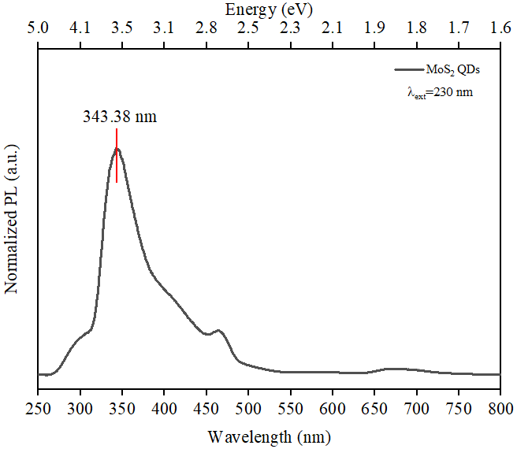

Figure 5: Typical PL spectrum of MoS2 QDs using Q-switched Nd:YAG laser in LN2.

The N-MoS2 QDs formation mechanism which relies on the pulsed laser-induced thermal shock waves and intercalation of N2 molecules into interlayers leading to exfoliation of flakes. Subsequently, sudden expansion takes place during laser exposure leading to the gaseous phase [22, 28]. Figure 6 depicts the covalent nitrogen doping of MoS2 QD during synthesizing of PLA in LN2 indicating the substitutional doping of N at the S sites on MoS2. In fact, the N-p and S-p states are intensely hybridized with the Mo-d states. Azcatl et al demonstrated the covalent nitrogen doping and compressive strain in MoS2 by remote N2 plasma exposure leading to successful p-type doping of MoS2 [45].

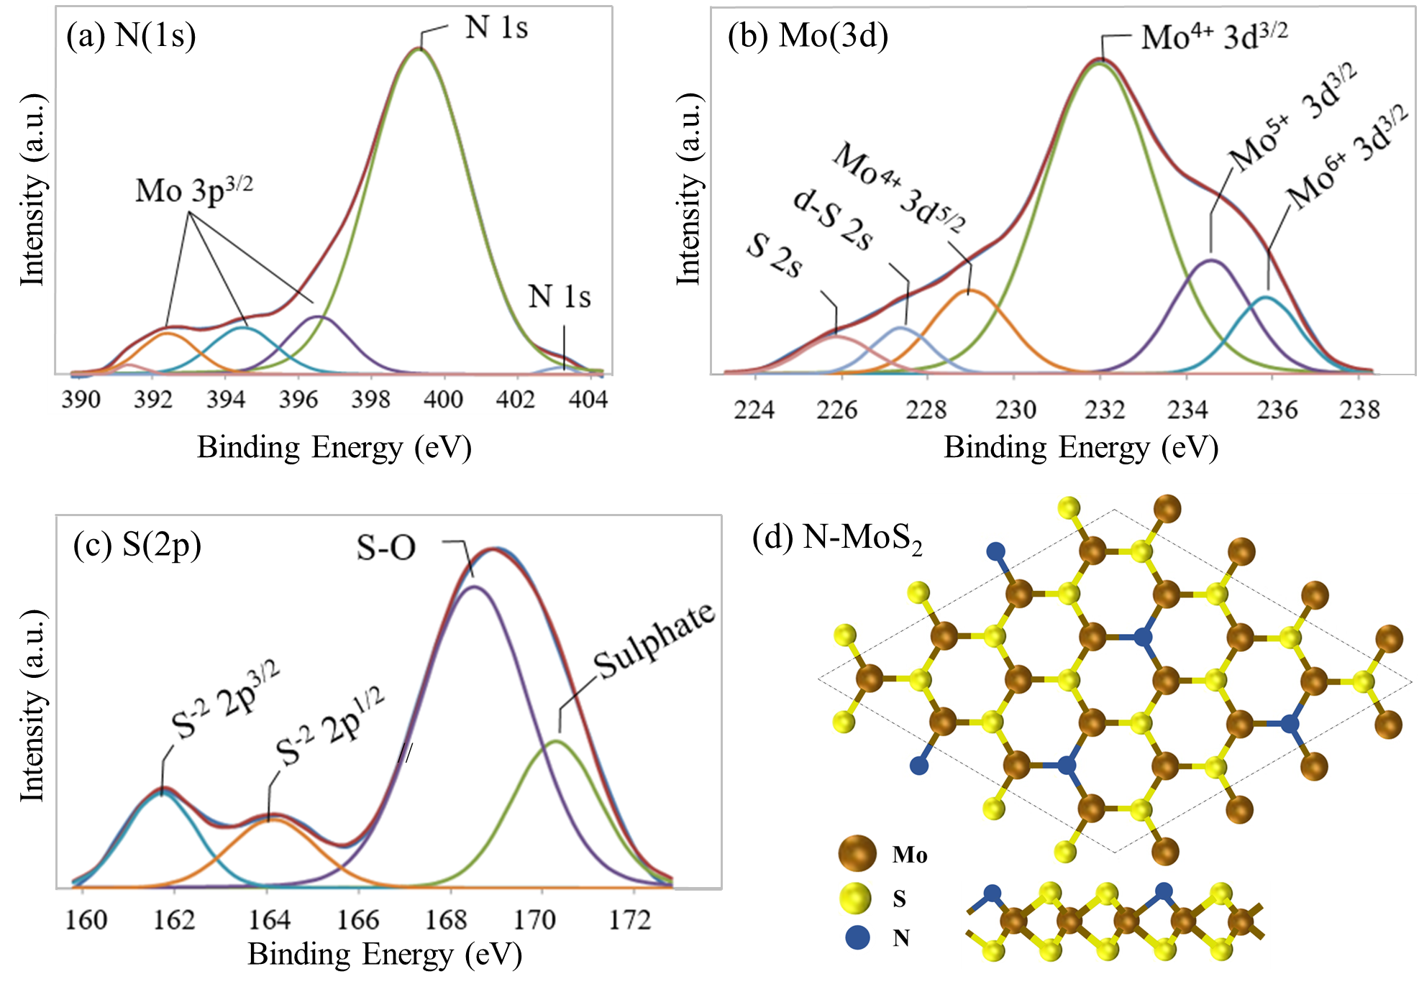

Figure 6: Schematic of top and side views of the covalent N-MoS2 QDs during synthesizing of PLA in LN2.

**Conclusions**

N-MoS2 QDs are synthesized by laser-induced intercalation and exfoliation of bulk MoS2 target in LN2 medium using the Q-switched pulsed Nd:YAG nanosecond laser at 1064 nm. The laser-induced plasma can treat the target surface to provide the reactive sites scaling up the nitrogen bondings leading to selective functionalization. It is worth noting that the ultrathin MoS2 QDs can be achieved by optimizing the parameters such as laser wavelength, irradiation time and the number of laser shots. The MoS2 structure generated by the PLA in cryogenic media enjoys a flexible, fast, single-stage and free chemical pollution process, accompanying easy products collection.

**References**

[1] K. K. Liu, W. Zhang, Y.-H. Lee, Y.-C. Lin, M.-T. Chang, C.-Y. Su, C.-S. Chang, H. Li, Y. Shi, and H. Zhang, Growth of large-area and highly crystalline MoS2 thin layers on insulating substrates, Nano letters, **12** (2012) 1538-1544.

[2] Y. Huang, J. Wu, X. Xu, Y. Ho, G. Ni, Q. Zou, G. K. W. Koon, W. Zhao, A. C. Neto, and G. Eda, An innovative way of etching MoS2: Characterization and mechanistic investigation, Nano Research, **6** (2013) 200-207.

[3] G. Eda, H. Yamaguchi, D. Voiry, T. Fujita, M. Chen, and M. Chhowalla, Photoluminescence from chemically exfoliated MoS2, Nano letters, **11** (2011) 5111-5116.

[4] Y. Hernandez, V. Nicolosi, M. Lotya, F. M. Blighe, Z. Sun, S. De, I. McGovern, B. Holland, M. Byrne, and Y. K. Gun'Ko, High-yield production of graphene by liquid-phase exfoliation of graphite, Nature nanotechnology, **3** (2008) 563.

[5] K. S. Novoselov, A. K. Geim, S. V. Morozov, D. Jiang, Y. Zhang, S. V. Dubonos, I. V. Grigorieva, and A. A. Firsov, "Electric field effect in atomically thin carbon films," science, **306** (2004) 666-669.

[6] A. Castellanos-Gomez, M. Barkelid, A. Goossens, V. E. Calado, H. S. van der Zant, and G. A. Steele, Laser-thinning of MoS2: on demand generation of a single-layer semiconductor, Nano letters, **12** (2012) 3187-3192.

[7] Y. Gong, B. Li, G. Ye, S. Yang, X. Zou, S. Lei, Z. Jin, E. Bianco, S. Vinod, and B. I. Yakobson, Direct growth of MoS2 single crystals on polyimide substrates, 2D Materials, **4** (2017) 021028.

[8] H. Li, H. Wu, S. Yuan, and H. Qian, Synthesis and characterization of vertically standing MoS 2 nanosheets, Scientific reports, **6** (2016) 21171.

[9] Y. Yu, C. Li, Y. Liu, L. Su, Y. Zhang, and L. Cao, Controlled scalable synthesis of uniform, high-quality monolayer and few-layer MoS2 films, Scientific reports, **3** (2013) 1866.

[10] Y. Zhan, Z. Liu, S. Najmaei, P. M. Ajayan, and J. Lou, Large‐area vapor‐phase growth and characterization of MoS2 atomic layers on a SiO2 substrate, Small, **8** (2012) 966-971.

[11] G. Deokar, D. Vignaud, R. Arenal, P. Louette, and J.-F. Colomer, Synthesis and characterization of MoS2 nanosheets, Nanotechnology, **27** (2016) 075604.

[12] R. Wang, Q. Shao, Q. Yuan, P. Sun, R. Nie, and X. Wang, Direct growth of high-content 1T phase MoS2 film by pulsed laser deposition for hydrogen evolution reaction, Applied Surface Science, **504** (2020) 144320.

[13] T. A. Loh, and D. H. Chua, Pulsed laser fabricated few-layer MoS2 on silver, Chemical Physics Letters, **610** (2014) 284-287.

[14] M. I. Serna, S. Moreno, M. Higgins, H. Choi, M. Minary‐Jolandan, and M. A. Quevedo‐Lopez, Growth parameter enhancement for MoS2 thin films synthesized by pulsed laser deposition, physica status solidi (c), **13** (2016) 848-854.

[15] K. Kang, S. Xie, L. Huang, Y. Han, P. Y. Huang, K. F. Mak, C.-J. Kim, D. Muller, and J. Park, High-mobility three-atom-thick semiconducting films with wafer-scale homogeneity, Nature, **520** (2015) 656-660.

[16] J. Hu, J. S. Zabinski, J. H. Sanders, J. E. Bultman, and A. A. Voevodin, Pulsed laser syntheses of layer-structured WS2 nanomaterials in water, The Journal of Physical Chemistry B, **110** (2006) 8914-8916.

[17] S. Barcikowski, F. Devesa, and K. Moldenhauer, Impact and structure of literature on nanoparticle generation by laser ablation in liquids, Journal of Nanoparticle Research, **11** (2009) 1883.

[18] G. Yang, Laser ablation in liquids: Applications in the synthesis of nanocrystals, Progress in Materials Science, **52** (2007) 648-698.

[19] S. Z. Mortazavi, P. Parvin, A. Reyhani, A. N. Golikand, and S. Mirershadi, Effect of laser wavelength at IR (1064 nm) and UV (193 nm) on the structural formation of palladium nanoparticles in deionized water, The Journal of Physical Chemistry C, **115** (2011) 5049-5057.

[20] W. Yin, L. Yan, J. Yu, G. Tian, L. Zhou, X. Zheng, X. Zhang, Y. Yong, J. Li, and Z. Gu, High-throughput synthesis of single-layer MoS2 nanosheets as a near-infrared photothermal-triggered drug delivery for effective cancer therapy, ACS nano, **8** (2014) 6922-6933.

[21] H. G. Baldovi, M. Latorre-Sánchez, I. Esteve-Adell, A. Khan, A. M. Asiri, S. A. Kosa, and H. Garcia, Generation of MoS2 quantum dots by laser ablation of MoS2 particles in suspension and their photocatalytic activity for H2 generation, Journal of Nanoparticle Research, **18** (2016) 240.

[22] S. Z. Mortazavi, P. Parvin, and A. Reyhani, Fabrication of graphene based on Q-switched Nd: YAG laser ablation of graphite target in liquid nitrogen, Laser Physics Letters, **9** (2012) 547.

[23] W. Xiao, P. Liu, J. Zhang, W. Song, Y. P. Feng, D. Gao, and J. Ding, Dual‐Functional N Dopants in Edges and Basal Plane of MoS2 Nanosheets Toward Efficient and Durable Hydrogen Evolution, Advanced Energy Materials, **7** (2017) 1602086.

[24] F. M. Enujekwu, Y. Zhang, C. I. Ezeh, H. Zhao, M. Xu, E. Besley, M. W. George, N. A. Besley, H. Do, and T. Wu, N-doping enabled defect-engineering of MoS2 for enhanced and selective adsorption of CO2: A DFT approach, Applied Surface Science, **542** (2021) 148556.

[25] Q. Liu, X. Weijun, Z. Wu, J. Huo, D. Liu, Q. Wang, and S. Wang, The origin of the enhanced performance of nitrogen-doped MoS2 in lithium ion batteries, Nanotechnology, **27** (2016) 175402.

[26] C. Hu, C. Yuan, A. Hong, M. Guo, T. Yu, and X. Luo, Work function variation of monolayer MoS2 by nitrogen-doping, Applied Physics Letters, **113** (2018) 041602.

[27] X. Fan, Y. Huang, H. Wang, F. Zheng, C. Tan, Y. Li, X. Lu, Z. Ma, and Q. Li, Efficacious nitrogen introduction into MoS2 as bifunctional electrocatalysts for long-life Li-O2 batteries, Electrochimica Acta, **369** (2021) 137653.

[28] F. Shahi, P. Parvin, S. Z. Mortazavi, A. Reyhani, B. Soltannia, M. Sadrzadeh, H. Moradi, A. Ojaghloo, and A. Moafi, Synthesis, characterization and typical application of nitrogen doped MoS2 nanosheets based on pulsed laser ablation in liquid nitrogen, physica status solidi (a), (2022)

[29] P. Zhang, B. Xu, G. Chen, C. Gao, and M. Gao, Large-scale synthesis of nitrogen doped MoS2 quantum dots for efficient hydrogen evolution reaction, Electrochimica Acta, **270** (2018) 256-263.

[30] A. Sunitha, P. Hajara, M. Shaji, M. Jayaraj, and K. Saji, Luminescent MoS2 quantum dots with reverse saturable absorption prepared by pulsed laser ablation, Journal of Luminescence, **203** (2018) 313-321.

[31] B. Li, L. Jiang, X. Li, P. Ran, P. Zuo, A. Wang, L. Qu, Y. Zhao, Z. Cheng, and Y. Lu, Preparation of monolayer MoS2 quantum dots using temporally shaped femtosecond laser ablation of bulk MoS2 targets in water, Scientific reports, **7** (2017) 1-12.

[32] V. Nguyen, Q. Dong, L. Yan, N. Zhao, and P. H. Le, Facile synthesis of photoluminescent MoS2 and WS2 quantum dots with strong surface-state emission, Journal of Luminescence, **214** (2019) 116554.

[33] K. Alexaki, A. Kostopoulou, M. Sygletou, G. Kenanakis, and E. Stratakis, Unveiling the Structure of MoS x Nanocrystals Produced upon Laser Fragmentation of MoS2 Platelets, ACS omega, **3** (2018) 16728-16734.

[34] A. V. Murugan, B. Kale, A. V. Kulkarni, L. B. Kunde, and V. Saaminathan, Novel approach to control CdS morphology by simple microwave-solvothermal method, Journal of Materials Science: Materials in Electronics, **16** (2005) 295-299.

[35] J. Tauc, R. Grigorovici, and A. Vancu, Optical properties and electronic structure of amorphous germanium, physica status solidi (b), **15** (1966) 627-637.

[36] K. Dileep, R. Sahu, S. Sarkar, S. C. Peter, and R. Datta, Layer specific optical band gap measurement at nanoscale in MoS2 and ReS2 van der Waals compounds by high resolution electron energy loss spectroscopy, Journal of Applied Physics, **119** (2016) 114309.

[37] M. Mahdavi, S. Kimiagar, and F. Abrinaei, Preparation of Few-Layered Wide Bandgap MoS2 with Nanometer Lateral Dimensions by Applying Laser Irradiation, Crystals, **10** (2020) 164.

[38] X. Ren, L. Pang, Y. Zhang, X. Ren, H. Fan, and S. F. Liu, One-step hydrothermal synthesis of monolayer MoS2 quantum dots for highly efficient electrocatalytic hydrogen evolution, Journal of Materials Chemistry A, **3** (2015) 10693-10697.

[39] M. J. Park, S.-G. Yi, J. H. Kim, and K.-H. Yoo, Metal–insulator crossover in multilayered MoS2, Nanoscale, **7** (2015) 15127-15133.

[40] A. Splendiani, L. Sun, Y. Zhang, T. Li, J. Kim, C.-Y. Chim, G. Galli, and F. Wang, Emerging photoluminescence in monolayer MoS2, Nano letters, **10** (2010) 1271-1275.

[41] D. Wang, X.-B. Li, D. Han, W. Q. Tian, and H.-B. Sun, Engineering two-dimensional electronics by semiconductor defects, Nano Today, **16** (2017) 30-45.

[42] Z. Wu, and Z. Ni, Spectroscopic investigation of defects in two-dimensional materials, Nanophotonics, **6** (2017) 1219-1237.

[43] N. Kang, H. P. Paudel, M. N. Leuenberger, L. Tetard, and S. I. Khondaker, Photoluminescence quenching in single-layer MoS2 via oxygen plasma treatment, The Journal of Physical Chemistry C, **118** (2014) 21258-21263.

[44] H. Nan, Z. Wang, W. Wang, Z. Liang, Y. Lu, Q. Chen, D. He, P. Tan, F. Miao, and X. Wang, Strong photoluminescence enhancement of MoS2 through defect engineering and oxygen bonding, ACS nano, **8** (2014) 5738-5745.

[45] A. Azcatl, X. Qin, A. Prakash, C. Zhang, L. Cheng, Q. Wang, N. Lu, M. J. Kim, J. Kim, and K. Cho, Covalent nitrogen doping and compressive strain in MoS2 by remote N2 plasma exposure, Nano letters, **16** (2016) 5437-5443.